**Exercise 2: Implementing the Factory Method Pattern**

**Scenario:**

You are developing a document management system that needs to create different types of documents (e.g., Word, PDF, Excel). Use the Factory Method Pattern to achieve this.

**Steps:**

1. **Create a New Java Project:**
   * Create a new Java project named **FactoryMethodPatternExample**.
2. **Define Document Classes:**
   * Create interfaces or abstract classes for different document types such as **WordDocument**, **PdfDocument**, and **ExcelDocument**.
3. **Create Concrete Document Classes:**
   * Implement concrete classes for each document type that implements or extends the above interfaces or abstract classes.
4. **Implement the Factory Method:**
   * Create an abstract class **DocumentFactory** with a method **createDocument ()**.
   * Create concrete factory classes for each document type that extends DocumentFactory and implements the **createDocument ()** method.
5. **Test the Factory Method Implementation:**
   * Create a test class to demonstrate the creation of different document types using the factory method.

**CODE**

// FactoryMethodExample.java

interface Document {

    void open ();

}

class WordDocument implements Document {

    @Override

    public void open () {

        System.out.println("Opening a Word document.");

    }

}

class PdfDocument implements Document {

    @Override

    public void open () {

        System.out.println("Opening a PDF document.");

    }

}

class ExcelDocument implements Document {

    @Override

    public void open () {

        System.out.println("Opening an Excel document.");

    }

}

abstract class DocumentFactory {

    public abstract Document createDocument ();

}

class WordDocumentFactory extends DocumentFactory {

    @Override

    public Document createDocument () {

        return new WordDocument ();

    }

}

class PdfDocumentFactory extends DocumentFactory {

    @Override

    public Document createDocument () {

        return new PdfDocument ();

    }

}

class ExcelDocumentFactory extends DocumentFactory {

    @Override

    public Document createDocument () {

        return new ExcelDocument ();

    }

}

public class FactoryMethodExample {

    public static void main (String [] args) {

        DocumentFactory wordFactory = new WordDocumentFactory ();

        Document word = wordFactory.createDocument();

        word. open ();

        DocumentFactory pdfFactory = new PdfDocumentFactory ();

        Document pdf = pdfFactory.createDocument();

        pdf. open ();

        DocumentFactory excelFactory = new ExcelDocumentFactory ();

        Document excel = excelFactory.createDocument();

        excel. open ();

    }

}

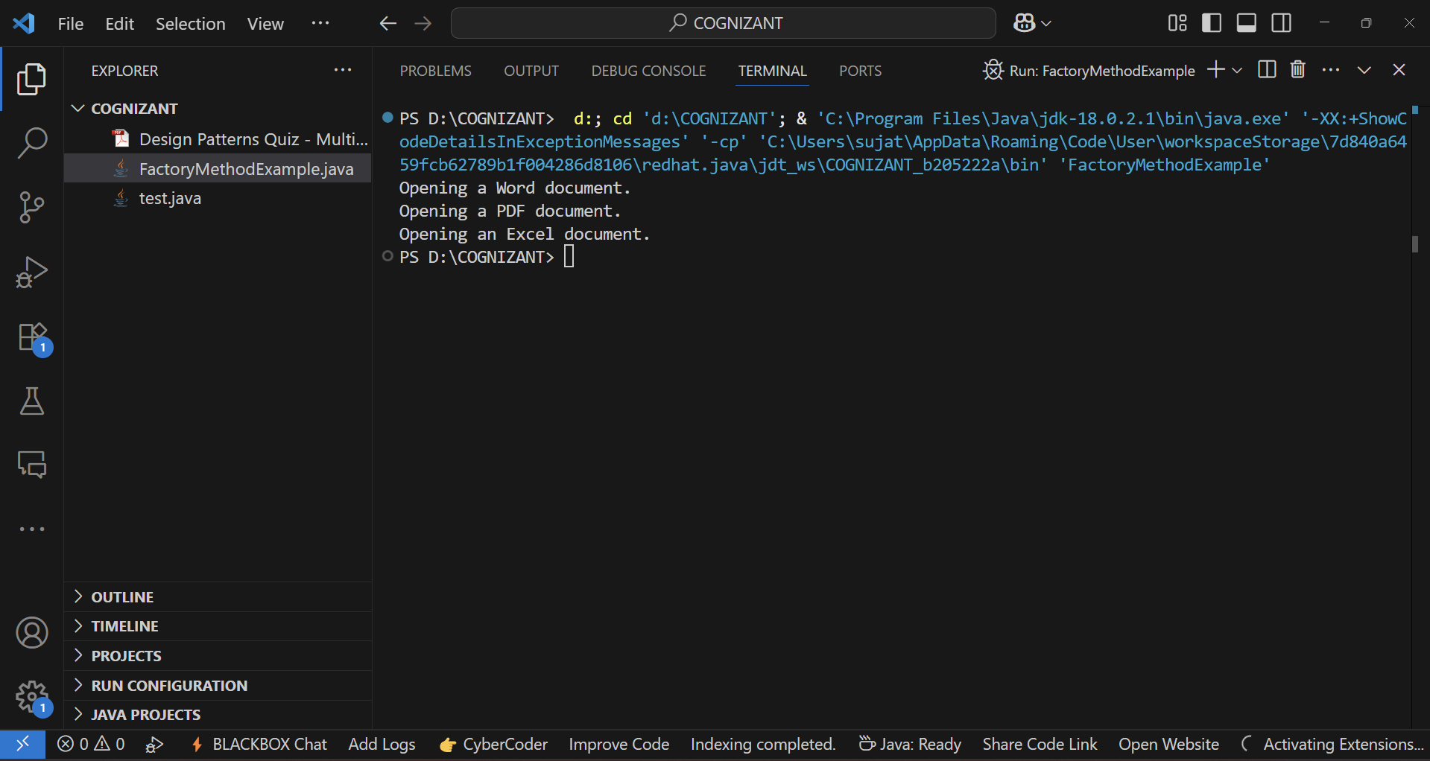**OUTPUT:-**